***Task2***

***Unit6***

Name: Rowida Abdulghani Ebrahem

Class:C5

School:WE_ El Mansoura

Date: 28/11/2024

***Introduction***

This report covers the design and development of a website for Beribolo Security, a company that sells and installs security systems. Due to the increasing demand for the company's services, the owners decided to improve the use of technology by creating a website that showcases their business and meets the needs of customers. The report covers identifying user needs, visual designs of the website, alternative design options, and technical documentation.

***Step 1: Identify User Needs***

**1.1 Business Owners’ Needs**

The owners of Berimbolo Security want their website to provide:

**Easy access to information:** The website should clearly show the services and products offered.

**Product Display:** The website should showcase the security systems the company sells and installs with detailed descriptions and photos.

**Customer Interaction**: The website should have a way for customers to contact us, request quotes, and book installation services.

**Customer Testimonials and Case Studies:** Add customer testimonials and success stories to build trust with new visitors.

**Mobile Friendly Design:** The website should be usable on mobile phones.

**Search Engine Optimization (SEO):** The website should be optimized to appear in search engine results.

**1.2 End User Needs**

End users of the website, such as homeowners and businesses, need:

**Clear and easy navigation:** The website should be easy to use with simple navigation between sections.

**Easy access to information:** Users should be able to quickly access details of products and services.

**Loading Speed ​​and Mobile Responsiveness**: The website should work quickly on all devices.

**Browsing Security:** Users should feel safe filling out contact forms or requesting quotes.

**Service Categories:** Services should be clearly categorized (e.g. “Home Security” and “Small Business Security”).

**Online Booking and Ordering:** Users should be able to request quotes and book services through the site.

***Step 2: Visual Designs of Pages***

**2.1 Design of Home Pages**

**Home Page :**Contains a large main image showing the installation of a security system with a “Request a Quote” button.

**Sections include:** Company Introduction, Featured Products, Customer Testimonials**,**Contact Form

**Site Colors:** Blue (to emphasize security), White (for a clean design), and Gray (to appear professional).

**Fonts:** Simple and clear fonts such as Arial or Calibri.

**Service Pages:**Each service page contains a detailed description of the security systems with images.

The features of each service are displayed with “Request a Quote” and “Book an Appointment” buttons.

**Contact Page:**Contains a contact form with fields for name, email, phone number, and message.

Includes a site map and address, with contact details such as phone number and email.

**2.2 Layouts and Designs**

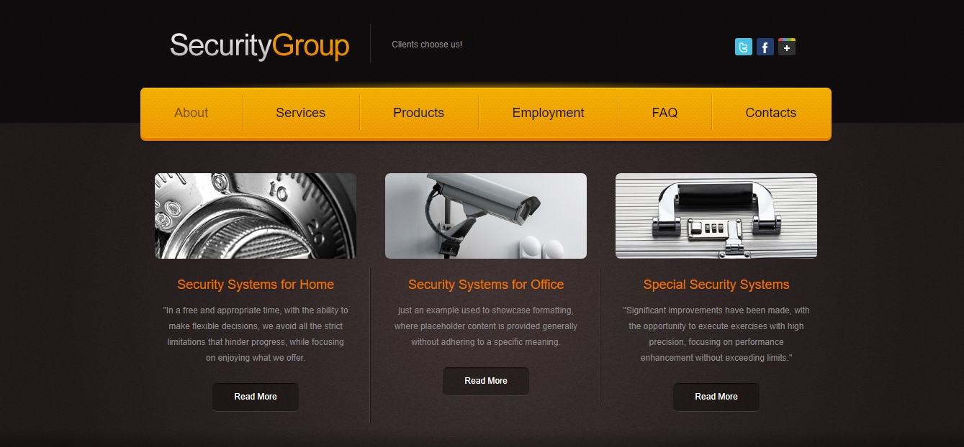

***Step 3: Alternative Design Options***

**3.1 Alternative Designs**

**Design 1:** Simple design with one large section displaying only the main product and testimonials. This design focuses on reducing visual clutter.

**Design 2:** Grid-based design, where services are displayed as clickable boxes. This design is more eye-catching.

**3.2 Alternative Colors**

**Design 1:** Use dark colors like black and gold to give the site a luxurious look.

**Design 2:** Use bright colors like orange and green to highlight safety and emergency.

***Step 4: Technical Documentation***

**4.1 Tools and Platforms**

**Development Tools:** HTML, CSS and JavaScript will be used to develop the front-end of the site, with React.js used to add interactive features if needed.

**Content Management System (CMS):**WordPress will be used to facilitate content management.

**4.2 Security Features**

**SSL Certificate:** To secure and protect user data.

**2-Factor Authentication:** To secure access to the control panel.

**4.3 Search Engine Optimization and Performance**

**Search Engine Optimization (SEO):** The site will be optimized to appear in search engines using keywords such as “home security systems” and “corporate security”.

**Performance Optimization:** Image compression and caching techniques will be used to speed up the site loading.

**4.4 Browser Compatibility**

The site will work with all modern browsers such as Google Chrome, Firefox, Safari and Edge.

**4.5 Mobile Compatibility**

**Responsive Design:** A responsive design will be used to ensure that the site is compatible with all devices from phones to computers.

***Conclusion***

This report aims to provide a comprehensive design for the Berimbolo Security website that meets the needs of employers and end users. The design focuses on improving the user experience, while ensuring the site is secure, mobile-friendly, and search engine-optimized. Alternative options provide flexibility in choosing the design that best suits the company’s brand identity and achieves its goals.